Question 1
Code:
import numpy as np
import matplotlib.pyplot as plt
points = np.array([
[1,3],
[2,2],
[5,8],
[8,5],
[3,9],
[10,7],
[3,3],
[9,4],
[3,7]
])

labels = ['P1','P2','P3','P4','P5','P6','P7','P8','P9']
centroids = np.array([
[3,3],
[3,7],
[9,4]
])

def euclidean_distance(a, b):
return np.sqrt(np.sum((a-b)**2))

K = 3
for iteration in range(2):
clusters = {i: [] for i in range(K)}
for idx, point in enumerate(points):
distances = [euclidean_distance(point, c) for c in centroids]
cluster_idx = np.argmin(distances)
clusters[cluster_idx].append(idx)

print(f"\nIteration {iteration+1}:")
for i in range(K):
print(f"Cluster {i+1}: {[labels[j] for j in clusters[i]]}")
for i in range(K):
if clusters[i]:
centroids[i] = np.mean(points[clusters[i]], axis=0)
print(f"Updated Centroids:\n{centroids}")
Output:
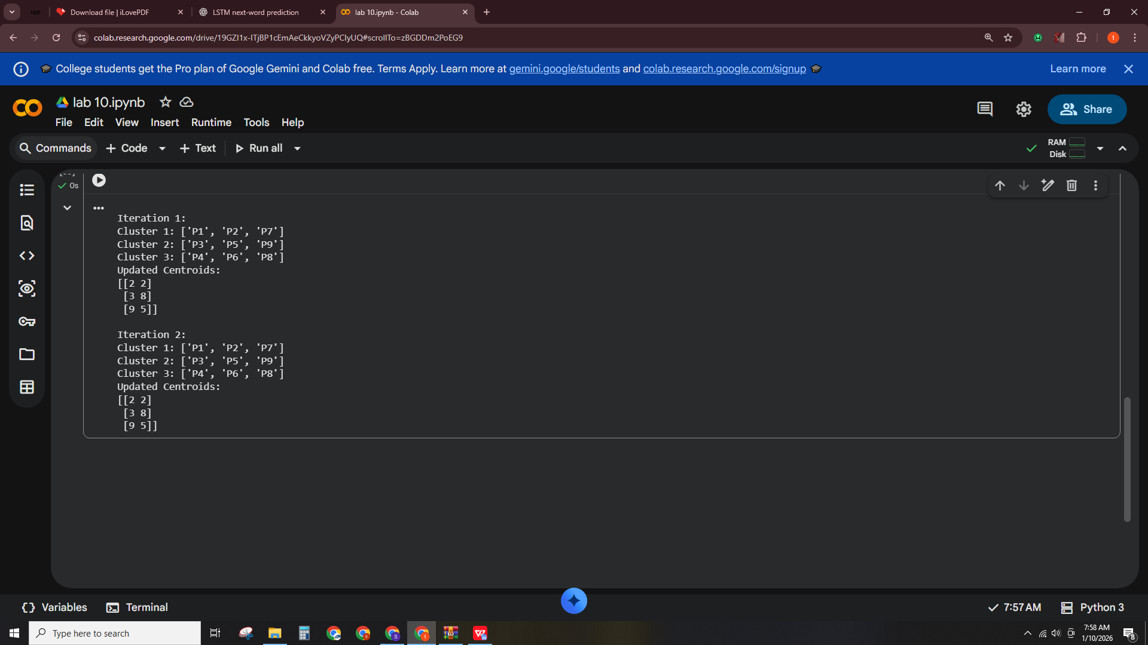
Code:
colors = ['r','g','b']
plt.figure(figsize=(8,6))
for i in range(K):
for idx in clusters[i]:
plt.scatter(points[idx][0], points[idx][1], color=colors[i], s=100)
plt.text(points[idx][0]+0.2, points[idx][1]+0.2, labels[idx])
for i, c in enumerate(centroids):
plt.scatter(c[0], c[1], color=colors[i], marker='X', s=200, edgecolor='k')
plt.text(c[0]+0.2, c[1]+0.2, f"C{i+1}", fontsize=12, fontweight='bold')

plt.title("K-Means Clustering (2 Iterations)")
plt.xlabel("X-axis")
plt.ylabel("Y-axis")
plt.grid(True)
plt.show()

Output:
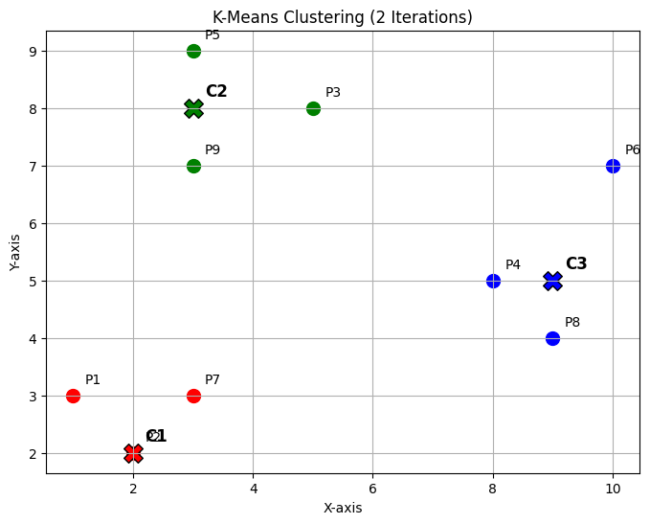
Question No. 2.
Code:
import numpy as np
import matplotlib.pyplot as plt
from sklearn.cluster import KMeans
points = np.array([
[1,3],
[2,2],
[5,8],
[8,5],
[3,9],
[10,7],
[3,3],
[9,4],
[3,7]
])
labels = ['P1','P2','P3','P4','P5','P6','P7','P8','P9']

def kmeans_cluster_plot(points, K):
kmeans = KMeans(n_clusters=K, random_state=42)
kmeans.fit(points)

centroids = kmeans.cluster_centers_
cluster_labels = kmeans.labels_
print(f"\nK = {K}")
for i in range(K):
cluster_points = [labels[j] for j in range(len(points)) if cluster_labels[j]==i]
print(f"Cluster {i+1}: Points {cluster_points}")
print(f"Centroid {i+1}: {centroids[i]}")
colors = ['r','g','b','c']
plt.figure(figsize=(6,5))
for i in range(K):
cluster_points = points[cluster_labels==i]
plt.scatter(cluster_points[:,0], cluster_points[:,1], color=colors[i], s=100, label=f'Cluster {i+1}')
for j, pt_idx in enumerate(np.where(cluster_labels==i)[0]):
plt.text(points[pt_idx][0]+0.2, points[pt_idx][1]+0.2, labels[pt_idx])
for i, c in enumerate(centroids):
plt.scatter(c[0], c[1], color=colors[i], marker='X', s=200, edgecolor='k')
plt.text(c[0]+0.2, c[1]+0.2, f"C{i+1}", fontsize=12, fontweight='bold')

plt.title(f"K-Means Clustering (K={K})")
plt.xlabel("X-axis")
plt.ylabel("Y-axis")
plt.legend()
plt.grid(True)
plt.show()

for K in [2,3,4]:
kmeans_cluster_plot(points, K)

Output:
A)
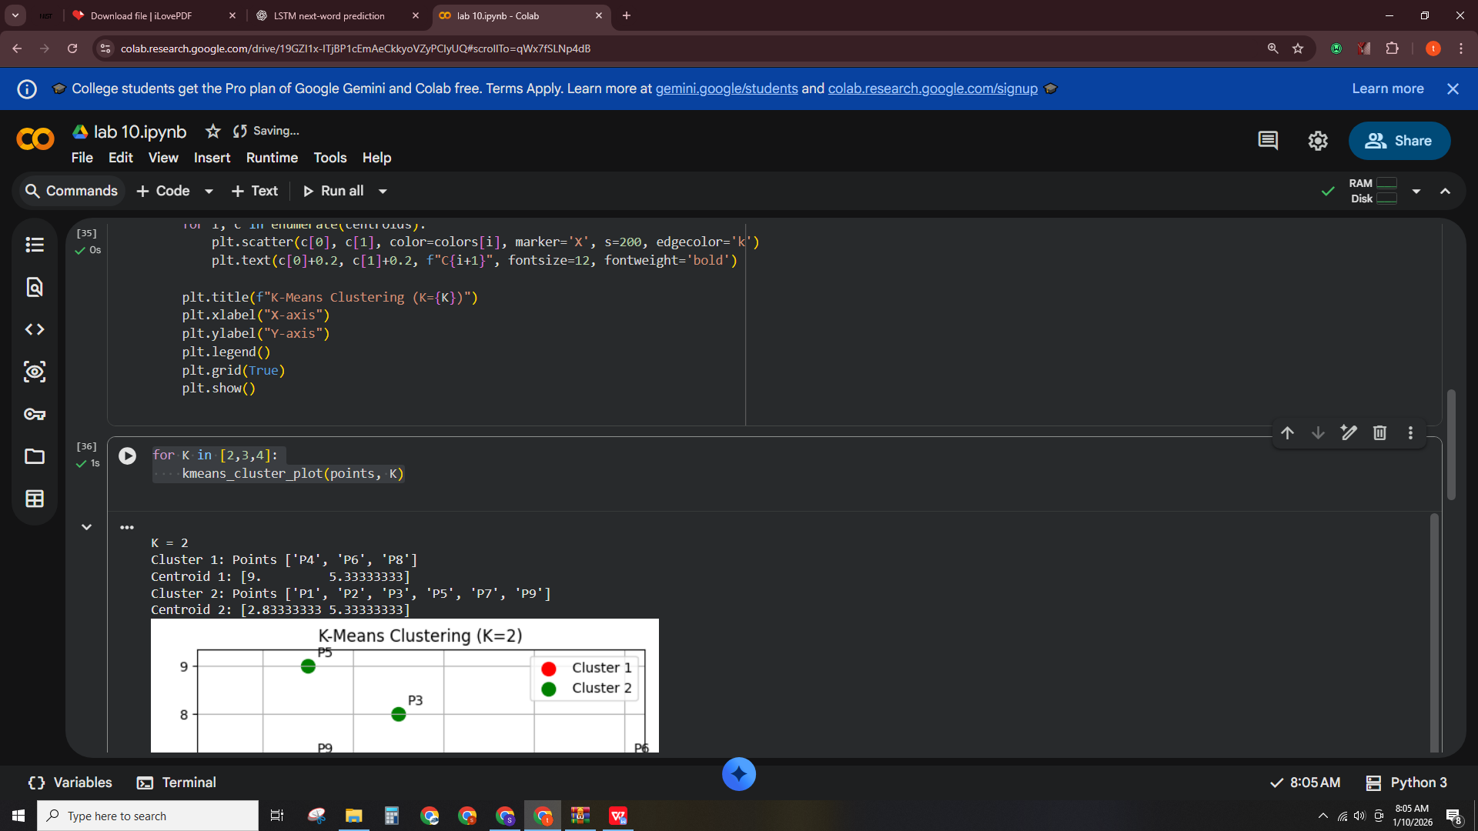
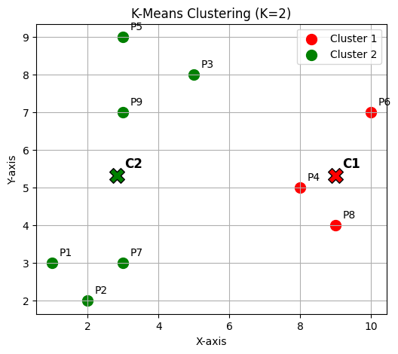
B)
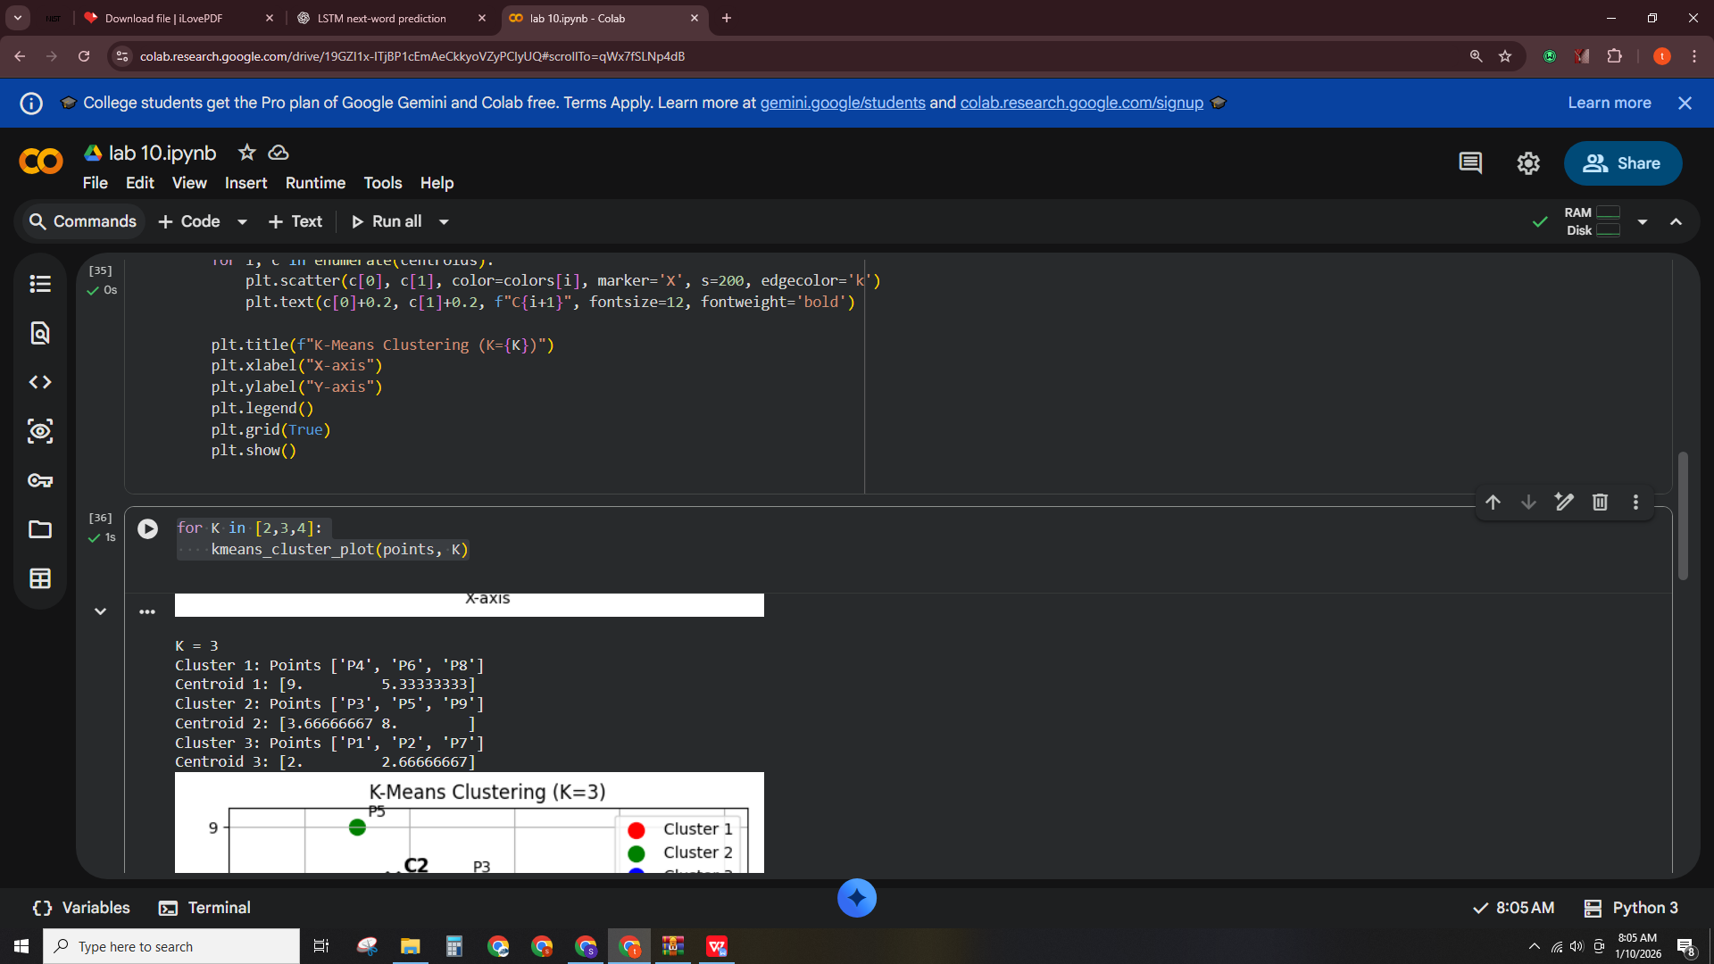
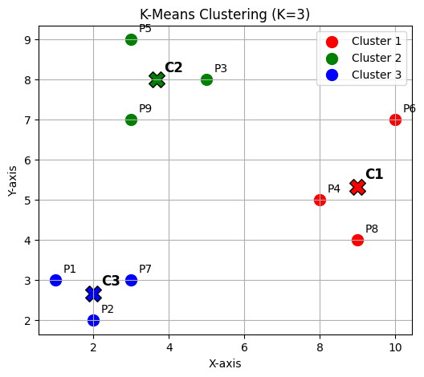
C)
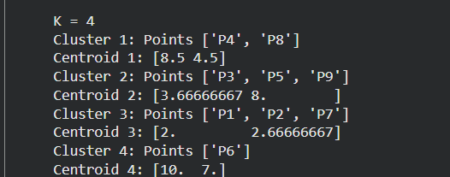
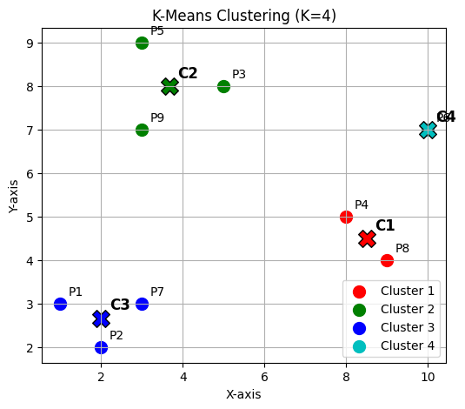
Code:
import numpy as np
import matplotlib.pyplot as plt
from sklearn.cluster import KMeans

points = np.array([
[1,3],
[2,2],
[5,8],
[8,5],
[3,9],
[10,7],
[3,3],
[9,4],
[3,7]
])
labels = ['P1','P2','P3','P4','P5','P6','P7','P8','P9']
points = np.vstack([points, [6,2]])
labels.append('P10')

kmeans = KMeans(n_clusters=3, random_state=42)
kmeans.fit(points)

centroids = kmeans.cluster_centers_
cluster_labels = kmeans.labels_

p10_cluster = cluster_labels[-1]
print(f"P10 belongs to Cluster {p10_cluster+1}")
for i, c in enumerate(centroids):
print(f"Centroid {i+1}: {c}")

Output:
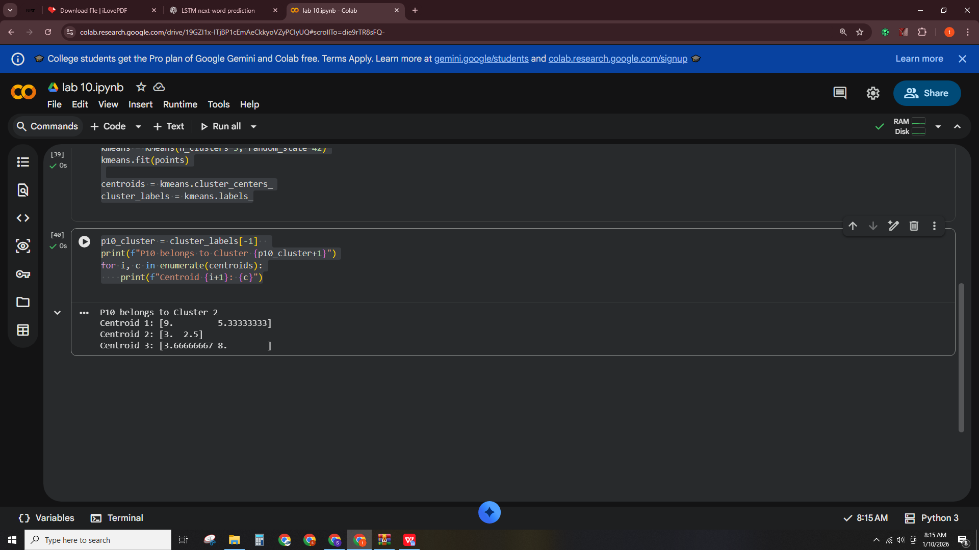
Code:
colors = ['r','g','b']
plt.figure(figsize=(7,6))
for i in range(3):
cluster_points = points[cluster_labels==i]
plt.scatter(cluster_points[:,0], cluster_points[:,1], color=colors[i], s=100, label=f'Cluster {i+1}')
for j, pt_idx in enumerate(np.where(cluster_labels==i)[0]):
plt.text(points[pt_idx][0]+0.2, points[pt_idx][1]+0.2, labels[pt_idx])
for i, c in enumerate(centroids):
plt.scatter(c[0], c[1], color=colors[i], marker='X', s=200, edgecolor='k')
plt.text(c[0]+0.2, c[1]+0.2, f"C{i+1}", fontsize=12, fontweight='bold')

plt.title("K-Means Clustering with New Point P10 (K=3)")
plt.xlabel("X-axis")
plt.ylabel("Y-axis")
plt.grid(True)
plt.legend()
plt.show()

Output:
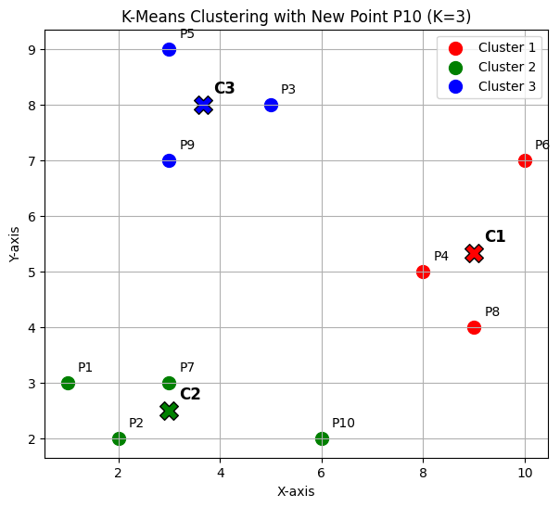Question 4 — Distance Table + First Iteration Manually
Code:
import numpy as np
import matplotlib.pyplot as plt

points = np.array([
[1,3],
[2,2],
[5,8],
[8,5],
[3,9],
[10,7],
[3,3],
[9,4],
[3,7]
])

labels = ['P1','P2','P3','P4','P5','P6','P7','P8','P9']
centroids = np.array([
[3,3],
[3,7],
[9,4]
])

def euclidean_distance(a, b):
return np.sqrt(np.sum((a-b)**2))
distance_table = []
assigned_clusters = []

for i, p in enumerate(points):
distances = [euclidean_distance(p, c) for c in centroids]
assigned_cluster = np.argmin(distances) + 1
distance_table.append(distances)
assigned_clusters.append(assigned_cluster)
distance_table = np.array(distance_table)

import pandas as pd

df = pd.DataFrame(distance_table, columns=['Dist to C1','Dist to C2','Dist to C3'])
df['Assigned Cluster'] = assigned_clusters
df['Point'] = labels
df = df[['Point','Dist to C1','Dist to C2','Dist to C3','Assigned Cluster']]

print(df)

Output:
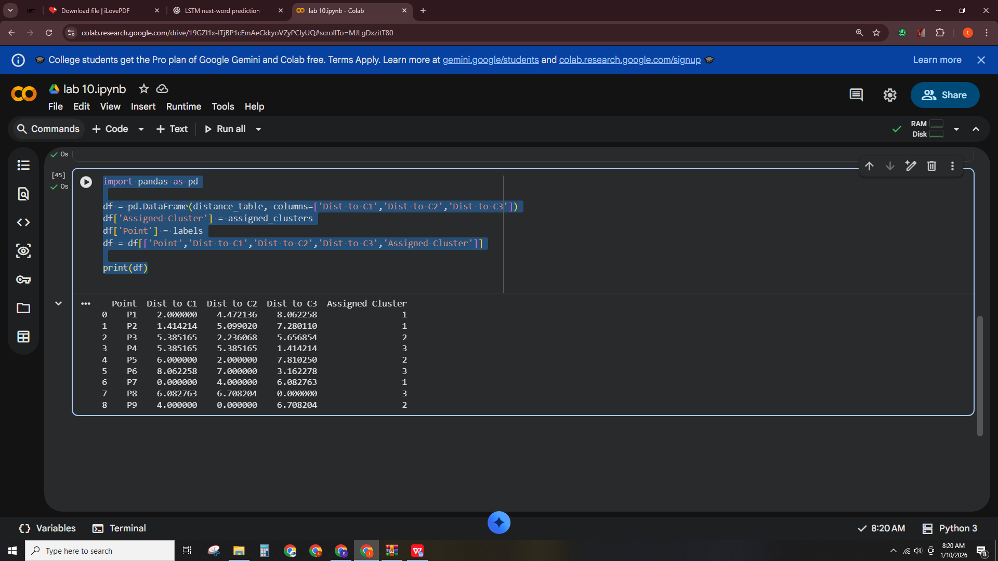
Code:
new_centroids = []

for k in range(1, 4):
cluster_points = points[np.array(assigned_clusters)==k]
new_c = np.mean(cluster_points, axis=0)
new_centroids.append(new_c)

new_centroids = np.array(new_centroids)
print("\nNew Centroids after 1st iteration:")
for i, c in enumerate(new_centroids):
print(f"C{i+1}: {c}")

Output:
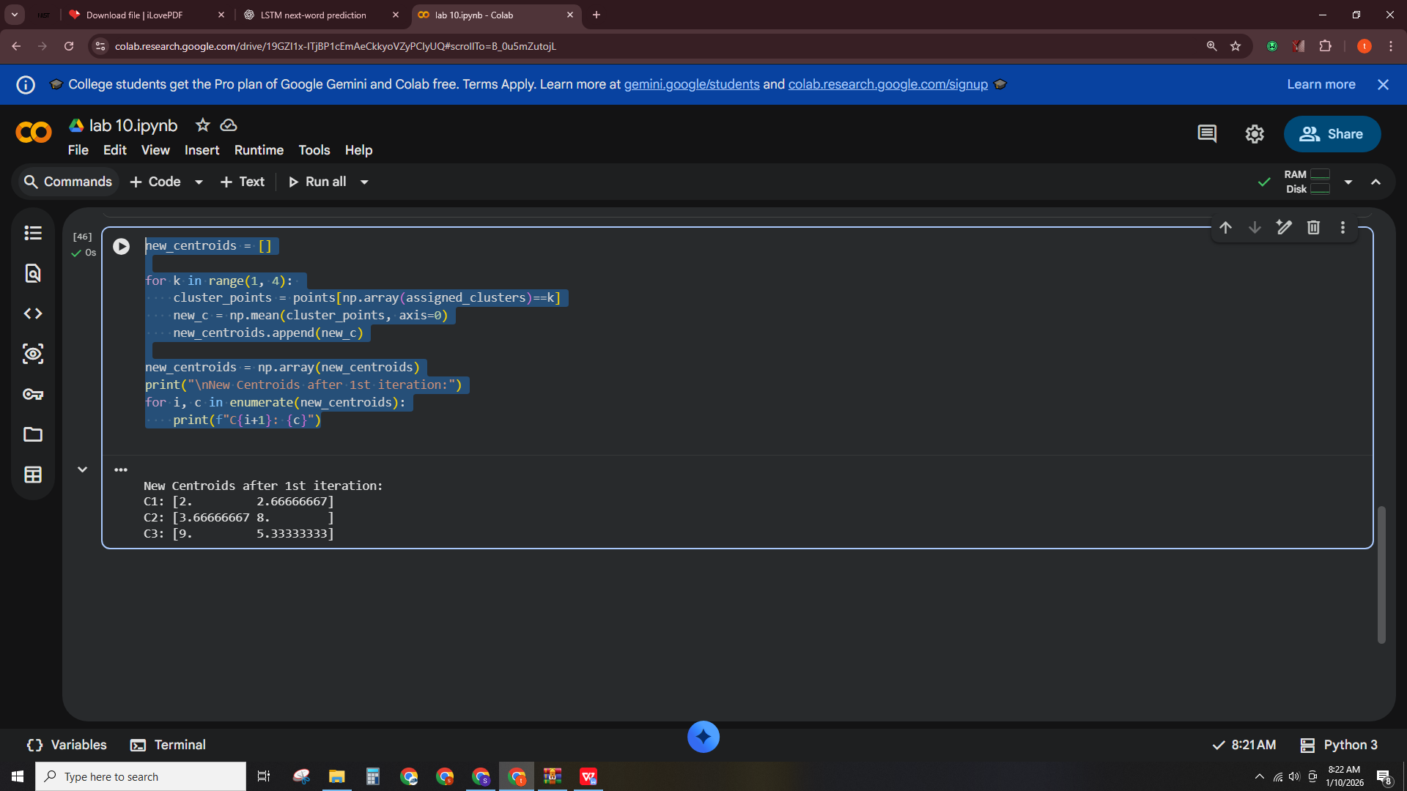
Code:
colors = ['r','g','b']
plt.figure(figsize=(8,6))
for i in range(1,4):
cluster_points = points[np.array(assigned_clusters)==i]
plt.scatter(cluster_points[:,0], cluster_points[:,1], color=colors[i-1], s=100, label=f'Cluster {i}')
for idx in np.where(np.array(assigned_clusters)==i)[0]:
plt.text(points[idx][0]+0.2, points[idx][1]+0.2, labels[idx])
for i, c in enumerate(new_centroids):
plt.scatter(c[0], c[1], color=colors[i], marker='X', s=200, edgecolor='k')
plt.text(c[0]+0.2, c[1]+0.2, f"C{i+1}", fontsize=12, fontweight='bold')

plt.title("K-Means First Iteration")
plt.xlabel("X-axis")
plt.ylabel("Y-axis")
plt.grid(True)
plt.legend()
plt.show()

Output:
